Data Model - Used Arrow Tool [<http://www.apcjones.com/arrows/#>]

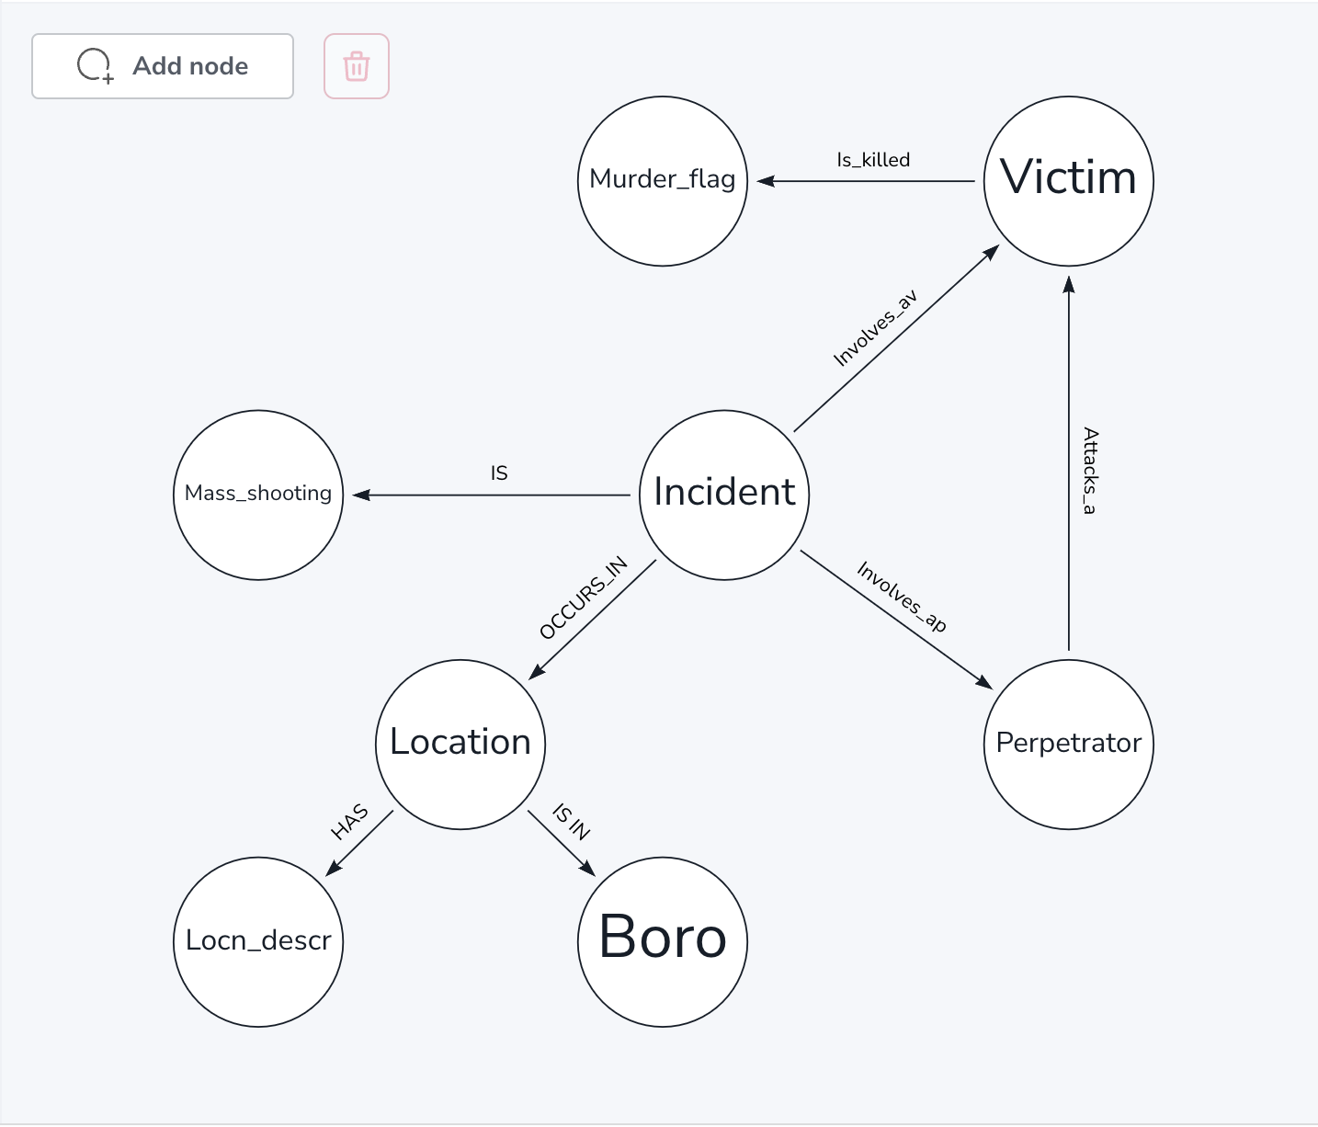

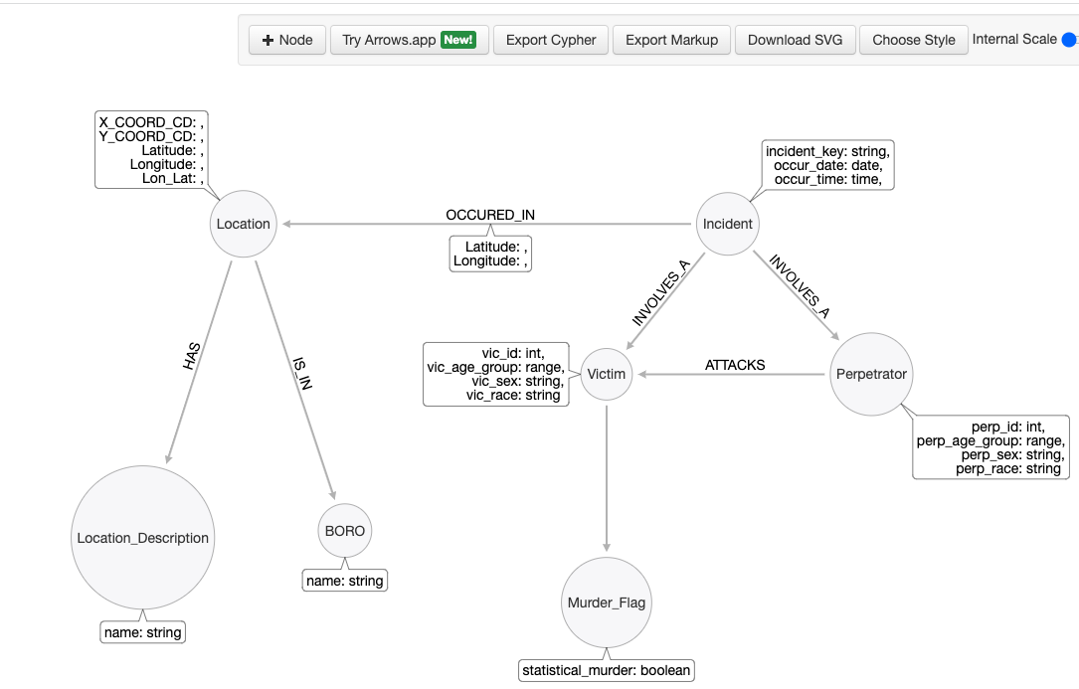

Creating nodes and relationships

Data model showing the relationship between the nodes

2. To identify the location in which maximum shooting incidents occurred in New York, matching the incidents and borough in which incidents took place.

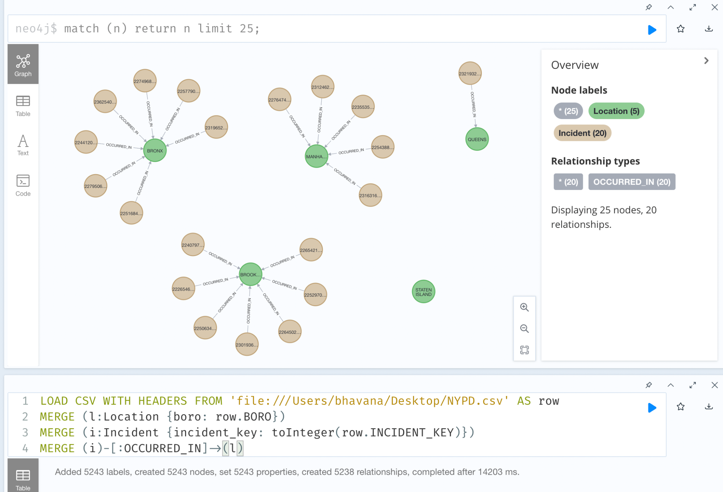

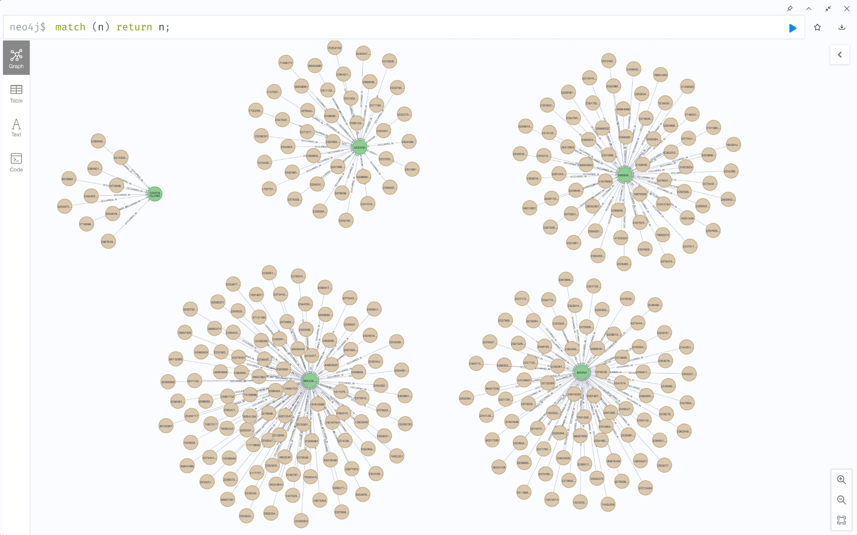

We can see that most shooting incidents occurred in **BROOKLYN** location in New York followed by **BRONX**

**AGGREGATE QUERIES:**

2. Finding (count)how many incidents occurred in each location (BORO) which is sorted in Descending order.

Cypher query:

LOAD CSV WITH HEADERS FROM 'file:///Users/bhavana/Desktop/NYPD.csv' AS row

return row.BORO, count(*)

order by count(*) desc;

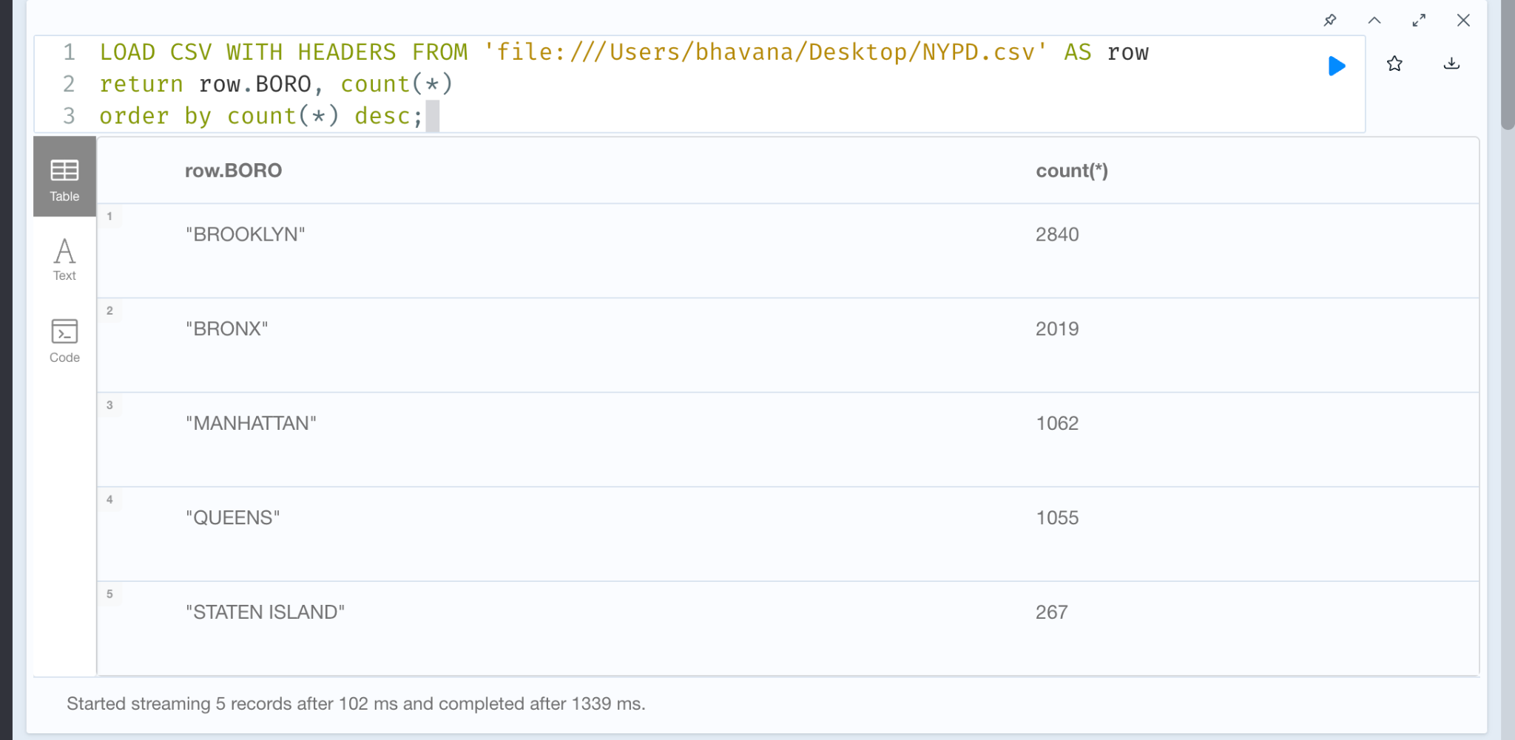

3. Checking for mass shootings. If there is a mass shooting, retrieve the incident_key, number of people affected and location of the incident sorted in the descending order of people affected.

Cypher Query:

LOAD CSV WITH HEADERS FROM 'file:///Users/bhavana/Desktop/NYPD.csv' AS row

return row.INCIDENT_KEY as incident_key , count(*) as people_affected, row.BORO as location,

order by count(*) desc;

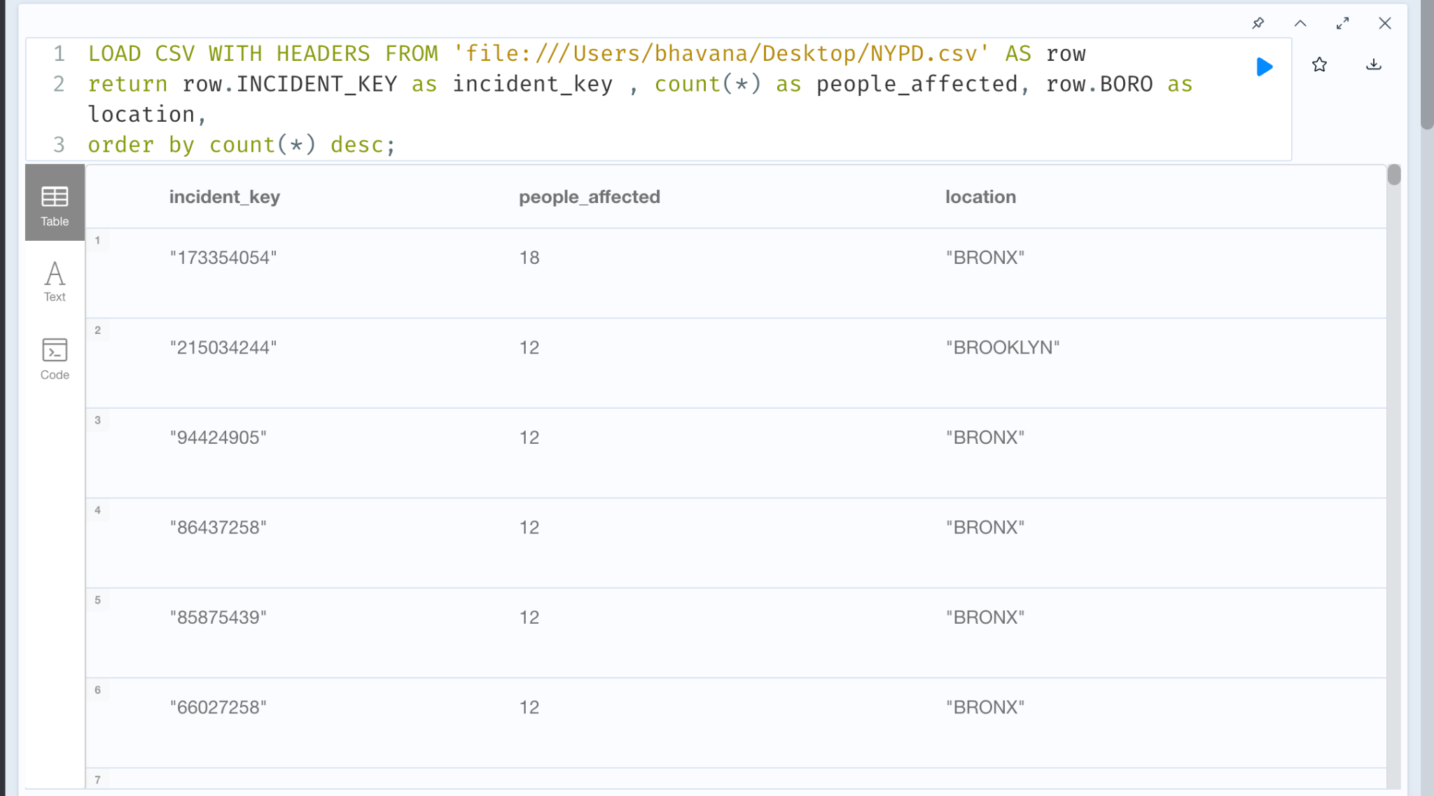

4. LOAD CSV WITH HEADERS FROM 'file:///Users/bhavana/Desktop/NYPD.csv' AS row

return row.BORO as location, row.VIC_SEX as victim_gender, count(*) as no_of_victims

order by no_of_victims desc;

